Luke Wilson  #25 Air City 16-1 Black  Outside/Opposite  Coach Jim Smith  tbolt1976@aol.com  Archbishop Alter High School  Class of 2021  Height: 6’2”  Weight: 180 | 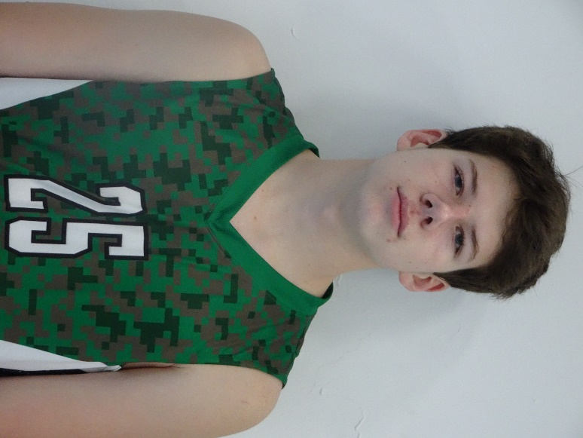
Athletic Information
Standing Reach: 7’10 Blocking Vertical: 10’1” Approach Vertical: 10’4”

Camps Attended: Air City VBC Men’s Camp 2018

Academic Information
GPA: 4.1/4.5 Class Rank: n/a
SAT Score: To be taken in 2020 ACT Score: To be taken in 2020
Academic Interest/Intended Major(s): Undecided
NCAA Clearinghouse Registration: No

To contact this athlete, send an email to aircityvolleyball@gmail.com. Please include your name, title, and institution. Emails will be forwarded to the player’s family for their consideration.

