Micah West  #19 Air City 17-1 Black  Libero/DS  Coach Tim O’Brien  tobrien4444@gmail.com  Green County Career Center  Class of 2020  Height: 5’9”  Weight: 130 | 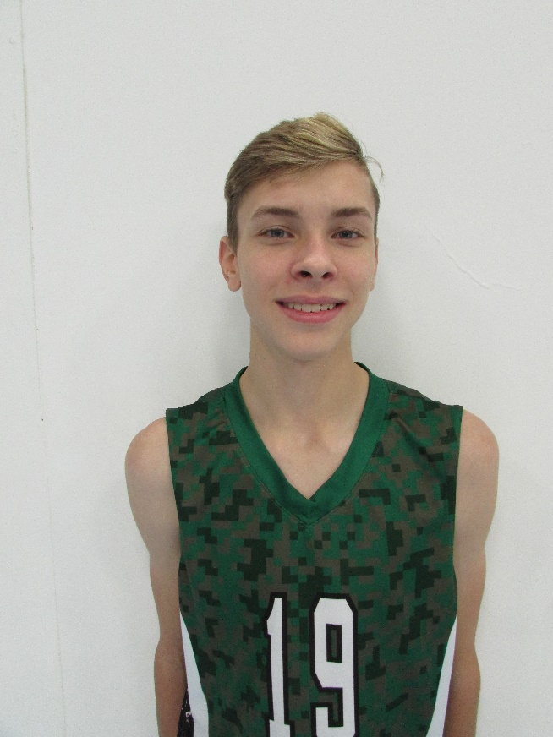
Athletic Information
Standing Reach: 7’9” Blocking Vertical: 9’7” Approach Vertical: 9’10”

Camps Attended:

Academic Information
GPA: n/a Class Rank: n/a
SAT Score: n/a ACT Score: n/a
Academic Interest/Intended Major(s): Undecided
NCAA Clearinghouse Registration: No

To contact this athlete, send an email to aircityvolleyball@gmail.com. Please include your name, title, and institution. Emails will be forwarded to the player’s family for their consideration.

