James Darnieder  #13 Air City 16-1 Black  Outside/Opposite  Coach Jim Smith  tbolt1977@aol.com  Archbishop Alter High School  Class of 2022  Height: 5’11”  Weight: 150 | 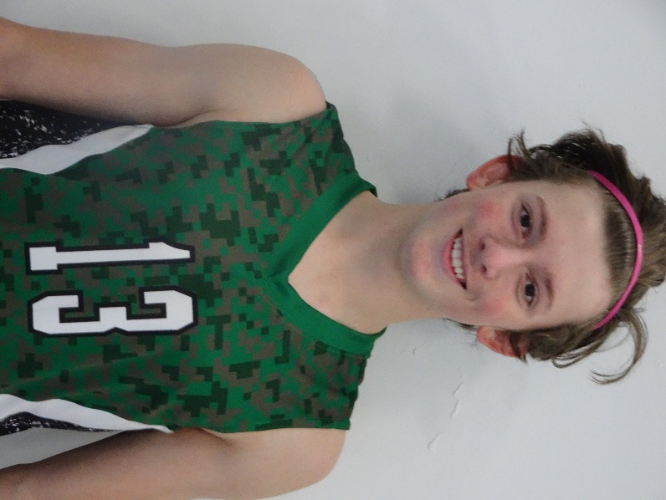
Athletic Information
Standing Reach: 7’8” Blocking Vertical: 9’7” Approach Vertical: 10’0”

Camps Attended: Ohio State University 2018

Player Awards: n/a

Academic Information
GPA: n/a Class Rank: n/a
SAT Score: To be taken in 2021 ACT Score: To be taken in 2021
Academic Interest/Intended Major(s): n/a
NCAA Clearinghouse Registration: No

To contact this athlete, send an email to aircityvolleyball@gmail.com. Please include your name, title, and institution. Emails will be forwarded to the player’s family for their consideration.

