Cannon Tucker  #20 Air City 17-1 Black  Opposite/Middle/Outside  Coach Tim O’Brien  tobrien4444@gmail.com  Dayton Carroll High School  Class of 2022  Height: 6’3”  Weight: 170 | 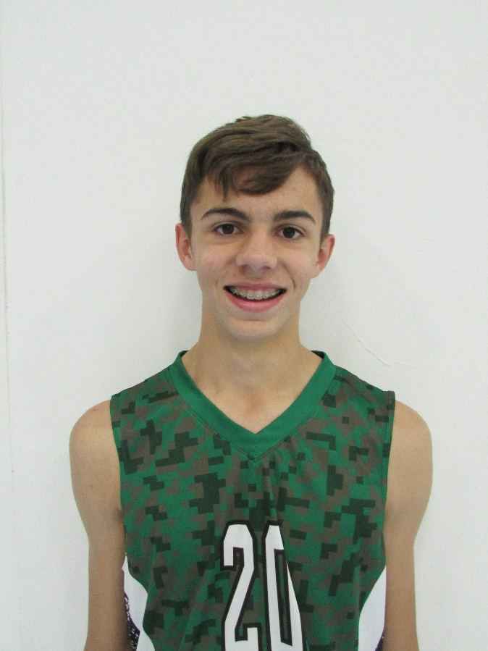
Athletic Information
Standing Reach: 8’5” Blocking Vertical: 10’7” Approach Vertical: 10’8”

2018 Ohio Valley Region High Performance Boys Select Team

Academic Information
GPA: 4.3/4.5 Class Rank: n/a
SAT Score: To be taken in 2021 ACT Score: To be taken in 2021
Academic Interest/Intended Major(s): n/a
NCAA Clearinghouse Registration: No

To contact this athlete, send an email to aircityvolleyball@gmail.com. Please include your name, title, and institution. Emails will be forwarded to the player’s family for their consideration.

