Collin Kepple  #8 Air City 17-1 Black  Outside/Opposite/Libero  Coach Tim O’Brien  tobrien4444@gmail.com  Archbishop Alter High School  Class of 2020  Height: 6’1”  Weight: 170 | 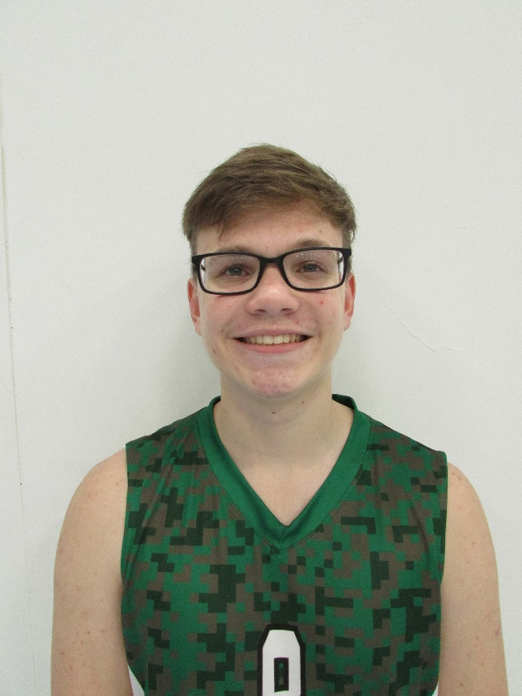
Athletic Information
Standing Reach: 7’8” Blocking Vertical: 9’8” Approach Vertical: 10’2”

Camps Attended: n/a

Awards: n/a

Academic Information
GPA: 3.80/4.00 Class Rank: n/a
SAT Score: To be taken May of 2019 ACT Score: 30
Academic Interest/Intended Major(s): Engineering, Psychology, Chemistry
NCAA Clearinghouse Registration: Yes

To contact this athlete, send an email to aircityvolleyball@gmail.com. Please include your name, title, and institution. Emails will be forwarded to the player’s family for their consideration.

