Nash Infanto  #35 Air City 18-2 Green  Outside/Opposite/Middle  Coach Becca Kuhlman  beccakuhlman7@gmail.com  Kettering Fairmont High School  Class of 2019  Height: 6’2”  Weight: 175 | 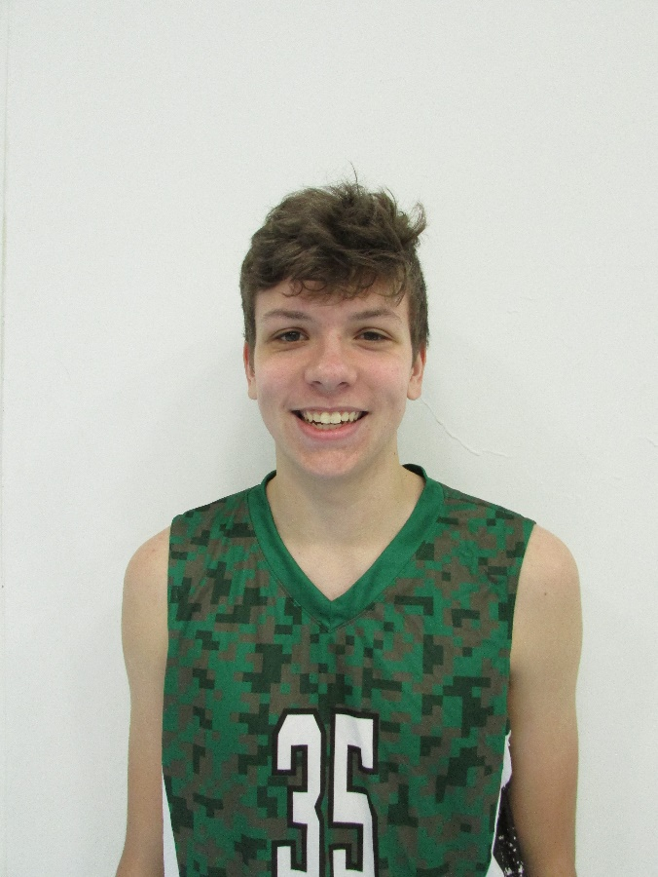
Athletic Information
Standing Reach: 8’3” Blocking Vertical: 10’4” Approach Vertical: 10’8”

Camps Attended: n/a

Awards: n/a

Academic Information
GPA: n/a Class Rank: n/a
SAT Score: n/a ACT Score: n/a
Academic Interest/Intended Major(s): n/a
NCAA Clearinghouse Registration: No

To contact this athlete, send an email to aircityvolleyball@gmail.com. Please include your name, title, and institution. Emails will be forwarded to the player’s family for their consideration.

