John Luers  #2 Air City 17-1 Black  Setter/Libero  Coach Tim O’Brien  tobrien4444@gmail.com  Bishop Fenwick High School  Class of 2021  Height: 5’8”  Weight: 140 | 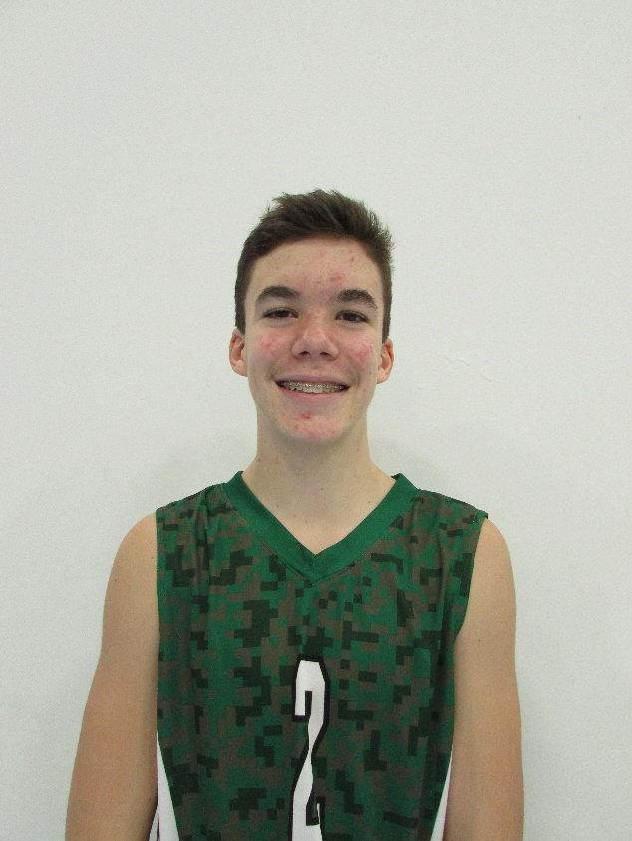
Athletic Information
Standing Reach: 7’5” Blocking Vertical: 9’3” Approach Vertical: 9’5”

Camps Attended: Ohio State University Men’s Camp 2018

Academic Information
GPA: 3.85/4.0 Class Rank: n/a
SAT Score: To be taken in 2020 ACT Score: To be taken in 2020
Academic Interest/Intended Major(s): Undecided
NCAA Clearinghouse Registration: No

To contact this athlete, send an email to aircityvolleyball@gmail.com. Please include your name, title, and institution. Emails will be forwarded to the player’s family for their consideration.

