Registration Form: One form per child  Name: _______________________________ Grade (2019-2020): ______ School: ________________________  Address: ___________________________________________________________________________________  Parent/Guardian Name: ________________________________ Cell/ Work # ___________________________  Email ______________________________________________________________________________________  SESSIONS: Junior High Clinic ALL DATES ___ OR individual dates July 15 ___ July 18 ___ July 25 ___  High School Clinic ALL DATES ___ OR individual dates July 15 ___ July 18 ___ July 25 ___  $30 per session OR $75 for ALL THREE sessions  Is there any reason your childs physical activity should be restricted? YES NO  Specify restriction ___________________________________________________________________________________________  Please list any known medical/ allergy conditions the Coaching Staff should know NONE or Specify condition ___________________________________________________________________________________________  Mail completed registration and payment to: Air City VBC 2019 Summer Clinics,  3037 Larue Drive, Kettering, OH 45429  Make checks payable to Air City Volleyball Club |  |  | 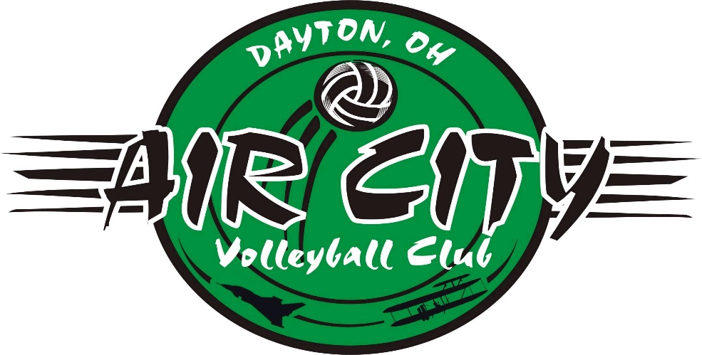  AIR CITY  VOLLEYBALL CLUB  2019 SUMMER CLINICS  July 15, 18, and 25, 2019 *  Middle School 5-7pm  High School 7-9pm  *minimum of 10 players needed for clinics to be held
ALL CLINICS WILL BE HELD AT CARROLL HIGH SCHOOL  4524 LINDEN AVENUE  DAYTON, OH 45432 |  |  | AIR CITY VOLLEYBALL CLUB  www.aircityvbc.com  Air City Volleyball Club is a Dayton-area program for boys, designed to teach and develop competitive volleyball. Our coaching staff consists of local school coaches, many of whom are current or former players themselves. They offer years of knowledge and experience to help our players learn and improve as individuals and teammates. Many former players have continued their participation in college at both the varsity and club level, as well as many adult programs. It is our mission to teach and promote the best of the sport of volleyball so that our players learn and appreciate its many great aspects.  UPCOMING EVENTS  (all dates to be announced)  High School Fall League  After Labor Day, we provide a 5-week league for “fun” and to “get back on the court” after the summer break. Players will be placed on teams and play one (possibly two) matches each night of the league.  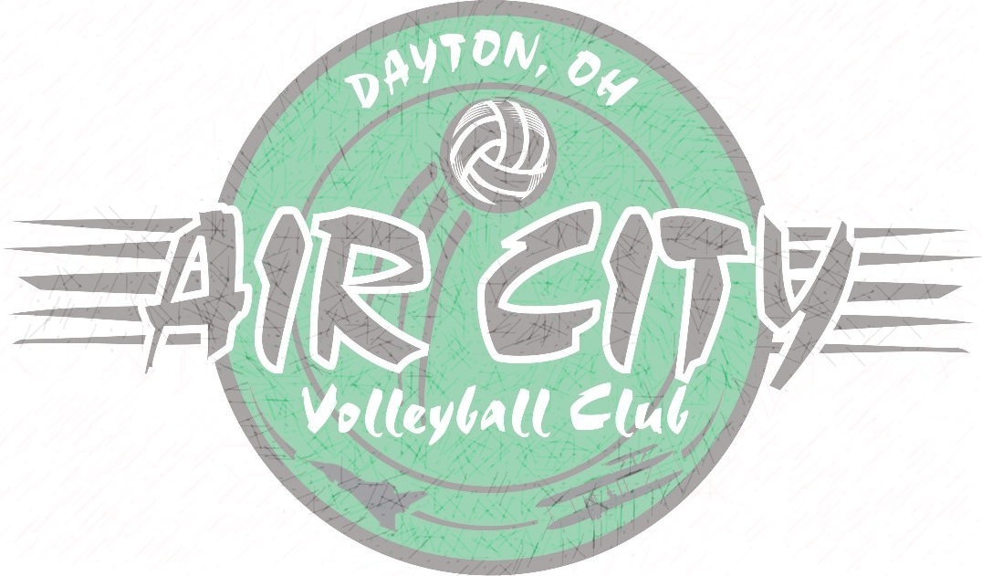  Middle School Fall Program  Also after Labor Day, we offer a 5 week series of skill training and competitive drills for boys grades eight and younger. The sessions will teach and reinforce good skill techniques as well as provide team-based drills common for competitive play.  Tryouts for Winter Club Teams  We will conduct tryouts for our winter club teams in mid-October at several area venues. Players wishing to pursue a position for one of these winter season teams need to attend one or more tryouts for evaluation by our coaching staff.  Individual or Small Group Personal Lessons  Several of our staff offer private one-hour lessons to individuals or small groups. Please email us at aircityvolleyball@gmail.com to schedule a lesson or for more information about how we can improve your volleyball player.
Our summer clinics will be directed by Carroll HS Coach Tim O’Brien with a staff of our area’s school and club coaches.
The clinics will focus on all around skill development. Players will train in various drills and challenges to increase their knowledge and performance in volleyball techniques.

Junior High All Skills Clinics
5:00-7:00pm
$30 per session ($75 for all 3 dates)

These junior high all skills clinics are for boys grades 5 through 8 (going into the 2019-20 school year). Basic and intermediate techniques will be taught so that players may learn and improve upon their serving, passing, setting, hitting, and digging.

High School All Skills Clinics
7:00-9:00pm
$30 per session ($75 for all 3 dates)

These skills clinics are for high school boys grades 9 through 12 (going into the 2019-2020 school year). Players should know the fundamentals of all skill sets and prepare to learn more advanced techniques, as well as learn the faster pace of the high school game.

