Anthony Sanfilippo  #29 Air City 16-1 Black  Middle/Setter/Outside  Coach Jim Smith  tbolt1977@aol.com  Beavercreek High School  Class of 2021  Height: 6’4”  Weight: 165 | 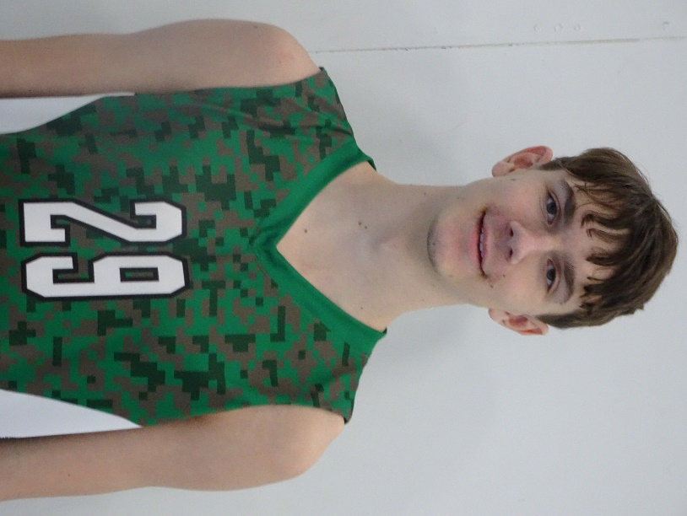
Athletic Information
Standing Reach: 8’3” Blocking Vertical: 10’4” Approach Vertical: 10’9”

Camps Attended: University of Dayton Camp, 2018

Awards: MVP Freshmen Team (Alter), MVP Junior Varsity Team (Alter)

Academic Information
GPA: 4.17/4.00 Class Rank: n/a
SAT Score: To be taken in 2021 ACT Score: To be taken 12/8/2018
Academic Interest/Intended Major(s): Engineering or Architecture
NCAA Clearinghouse Registration: No

To contact this athlete, send an email to aircityvolleyball@gmail.com. Please include your name, title, and institution. Emails will be forwarded to the player’s family for their consideration.

